

**WINTER SEMESTER 2022-2023**

**SCHOOL OF ELECTRONICS ENGINEERING (SENSE)**

**ECE3009 – NEURAL NETWORKS AND FUZZY CONTROL**

**PROJECT REPORT**

**ALVEOLI INFECTION DETECTION USING CNN**

**BY**

**TEAM – FANTASTIC FIVE**

**Submitted to DR. VAEGAE NAVEEN KUMAR**

**Slot : F1+TF1**

**TEAM MEMBERS**

1) Piyush Kumar(20BEC0471), 9661152166, piyush.kumar2020@vitstudent.ac.in

2) Aman Sethia(20BEC0583), 9507207344, aman.sethia2020@vitstudent.ac.in

**3) Arjeet Anand(20BEC0599), 7004253767,** **arjeet.anand2020@vitstudent.ac.in**

4) Naman Chopra(20BEC0360), 8847474520, naman.chopra2020@vitstudent.ac.in

5) Akshath Sharma(20BEC0463), 9318425161, akshath.sharma2020@vitstudent.ac.in

* **MOTIVATION OF THE PROJECT**

Alveoli infection causes inflammation of the air sacs in one or both lungs. When the air sacs are filled with fluid or pus, it can cause a cough with phlegm or pus, fever, chills, and difficulty breathing (purulent material). It continues to have a terrible impact on people's lives across the world, exposing the fragility of healthcare services worldwide and it is critical to create an automated and early diagnosis system that can make quick judgments while reducing diagnostic errors. According to the World Health Organization (WHO), lower respiratory tract infections, including alveoli infection, are responsible for over 3.5 million deaths per year, making it the leading cause of death among all infectious diseases worldwide. Early and accurate detection of alveoli infection can lead to better outcomes for patients and help reduce the burden on healthcare systems. Currently, the detection of alveoli infection relies on radiological expertise and visual interpretation of medical images by trained medical professionals. However, this process can be time-consuming and subject to interpretation bias. A computer-aided detection system using deep learning techniques such as convolutional neural networks (CNNs) can potentially aid in the accurate and timely detection of alveoli infection. According to a study published in the Journal of Thoracic Disease, deep learning models using CNNs achieved a high level of accuracy in detecting alveoli infection from CT images. The study found that the CNN model achieved an area under the receiver operating characteristic (ROC) curve of 0.96, demonstrating its potential as a reliable diagnostic tool. The potential benefits of using a deep learning model to detect alveoli infection include improved accuracy and speed of diagnosis, reduced interpretation bias, and potential cost savings for healthcare systems. As such, the project's motivation is to develop a deep learning model that can accurately detect alveoli infection from medical images and potentially improve patient outcomes.

* **RESEARCH GAPS**
* Lack of Diversity in the Dataset: The dataset used for training the CNN model might not be diverse enough to capture the variations in the images of infected alveoli. This can lead to a biased model and reduced accuracy.
* Limited Availability of Data: Since the project involves detecting infections in alveoli, obtaining a large amount of labelled data might be challenging. This can limit the potential of the model to generalize to new and unseen data.
* Inadequate Pre-processing Techniques: The quality of the input data can significantly affect the performance of a CNN model. Inadequate pre-processing techniques, such as image normalization, resizing, and filtering, can result in noisy or distorted images, which can negatively impact the model's accuracy.
* Overfitting and Underfitting: Overfitting occurs when the model becomes too complex and starts to fit the training data too well, resulting in poor generalization to new data. Underfitting, on the other hand, occurs when the model is too simple and fails to capture the patterns in the data. Both overfitting and underfitting can affect the model's accuracy and robustness.
* Lack of Explainability: CNN models are known for their black-box nature, which makes it difficult to interpret the decisions made by the model. This lack of explainability can limit the usability of the model in clinical settings, where doctors need to understand the reasons behind the model's decisions.
* Need for Real-Time Processing: In clinical settings, real-time processing is often required to enable quick decision-making. However, CNN models can be computationally intensive and may not be suitable for real-time processing, especially if the hardware resources are limited.
* Inadequate Knowledge about ALVEOLI: Alveoli are tiny sacs located at the end of the respiratory tree that are responsible for gas exchange between the lungs and the bloodstream. When infected, alveoli can become inflamed and filled with fluid, leading to difficulty breathing and other respiratory symptoms. For the project to be successful, it would be necessary to have a deep understanding of the structure and function of alveoli to accurately detect infection from medical images. Therefore, further research into the biology and physiology of alveoli could potentially fill this knowledge gap and improve the accuracy of the detection model. Specifically, research into the pathophysiology of alveolar infection and the specific imaging features associated with it could aid in the development of an accurate and reliable detection model using CNNs.
* **AIM AND OBJECTIVES**

The aim of the project "**Alveoli Infection Detection Using CNN using Python**" is to develop a machine learning model that can accurately detect infections in alveoli using a dataset of medical images. The project aims to create a CNN model that can classify images of alveoli as either infected or not infected with high accuracy. The main goal is to aid in the diagnosis and treatment of respiratory diseases, such as pneumonia, which can affect the alveoli. The project will involve pre-processing the dataset, developing, and training a CNN model, optimizing the model's hyperparameters and architecture, testing its performance, and potentially integrating it into a clinical setting. To achieve this aim, the project involves obtaining a diverse dataset of medical images of alveoli, both infected and non-infected, and pre-processing it using appropriate techniques. A CNN model will be developed using Python and trained on the pre-processed dataset to accurately classify images of alveoli as either infected or non-infected. The model's performance will be evaluated using appropriate metrics, and its hyperparameters and architecture will be optimized for optimal performance. Additionally, the project aims to interpret the model's decisions to provide insights into the features that contribute to the detection of alveoli infection. The potential integration of the model into a clinical setting to aid in the diagnosis and treatment of respiratory diseases is also a goal of this project.

The project's successful completion will result in the development of a robust and accurate machine learning model that can aid in the detection of alveoli infections, potentially improving the quality of care provided to patients with respiratory diseases. This project has the potential to have a significant impact on public health by providing an efficient and accurate diagnostic tool for respiratory diseases that can lead to timely treatment and improved patient outcomes.

The following are the objectives for the project "Alveoli Infection Detection Using CNN ":

1. Obtain a diverse dataset of medical images of alveoli, both infected and non-infected, with appropriate labels.
2. Pre-process the dataset using appropriate techniques such as normalization, resizing, and filtering.
3. Develop a CNN model using Python and appropriate libraries, such as TensorFlow or Keras.
4. Train the CNN model using the pre-processed dataset and evaluate its performance using appropriate metrics, such as accuracy, precision, recall, and F1-score.
5. Optimize the model by fine-tuning its hyperparameters and architecture to achieve the best possible performance.
6. Test the model on a separate set of images to evaluate its generalization ability.
7. Interpret the model's decisions and provide insights into the features that contribute to the detection of alveoli infection.
8. Potentially integrate the model into a clinical setting to aid in the diagnosis and treatment of respiratory diseases.

* **METHODOLOGY**

**Step 1: Choose a Dataset**

Our dataset has chest x ray images which have been divided into 3 files test, train and validation , the training dataset has 89.07% of total images , testing set has 10.6% of images and validation set has 0.27% of total images .These images in these folders are further divided into 2 parts one has NORMAL chest x-rays and rest are in ALVEOLI INFECTED folder based on the information already provided to us we downloaded this dataset from Kaggle

**Step 2: Prepare Dataset for Training**

Preparing our dataset for training will involve assigning paths and creating categories(labels), resizing our images. Resizing our images into 200*200

**Step 3: Create Training Data**

Training is an array that will contain image pixel values and the index at which the image in the Train Directory

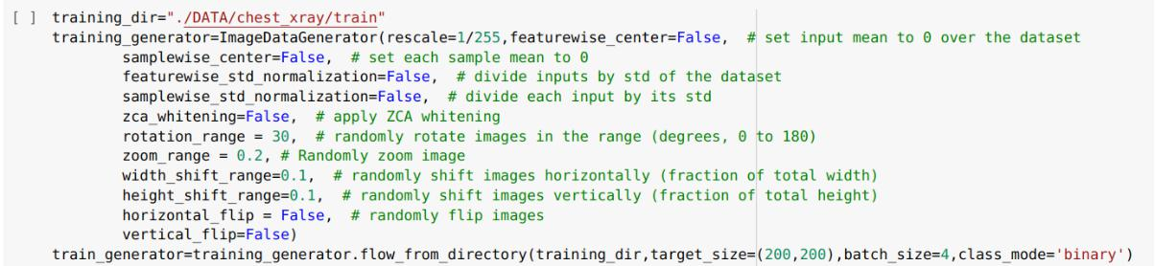

**Step 4: Shuffle the Dataset**

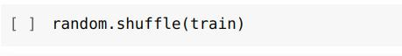

**Step 5: Assigning Labels and Features**

This shape of both the lists will be used in Classification using the NEURAL NETWORKS.

**Step 6: Normalising X and converting labels to categorical data**

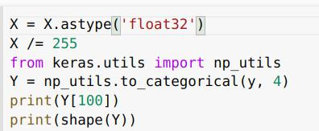

**Step 7: Split X and Y for use in CNN**



**Step 8: Define, compile and train the CNN Model**

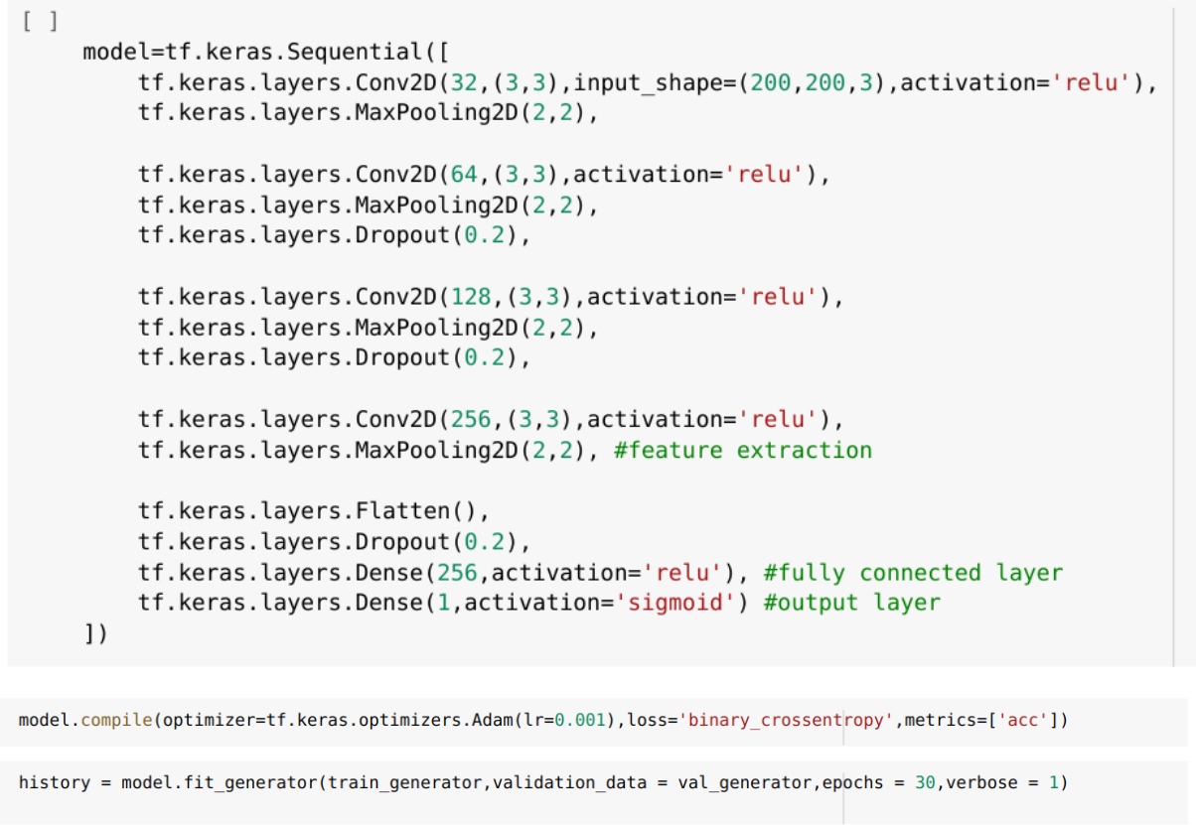

* **DATASET EXPLANATION**

**DATASET LINK:**

<https://www.kaggle.com/paultimothymooney/chest-xray-pneumonia>

Dataset Collection: We have used one of the datasets available on kaggle the link is given above ,the data there has been collected by Guangzhou Women and Children’s Medical Centre

Dataset division : To validate the model we have divided the dataset into 3 parts training, testing and validation where training has 89.07% of total images,testing 10.6% of images , validation set has 0.27% of total images.

Input Structure for Learning Model:The image entry in the model is in the form of an array of grayscale images( rgb values from 0-255)

Training Structure:We are using the sequential model where first we have added a lot of layers in the following order , In the first stage we have the convolutional layer, which is one of the main layers, where it is the extraction of characteristics of the image through a series of filters (kernels). A filter is an array of values, called weights, trained to detect specific features. The filter moves over each part of the image to see if the feature that it should detect is present.After the convolution layer is the pooling layer, which is responsible for reducing the spatial size of the feature map, preserving the resources detected in a smaller representation. There are several pooling layer options, with maxpooling being the most popular. Basically, maxpooling operates by locating the locations in the image that show the strongest correlation for each resource (the maximum value) are preserved and those maximum values combine to form a smaller space After that we have the flatten layer which flattens the multidimensional input tensors into a single dimension,Then lastly we have the dense layer which feeds all the output from the previous layer to all its neurons.

Future Prospect :We plan on hosting this model and forming a GUI where any such x-ray image entered can be quickly detected for alveoli infection presence.

* **FLOW CHART**

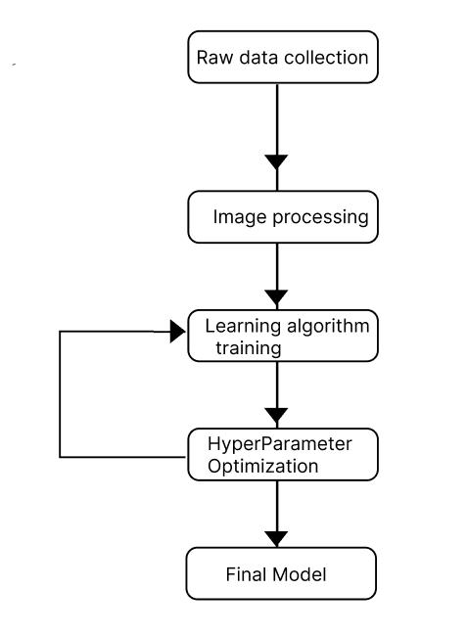

* **RESULTS**

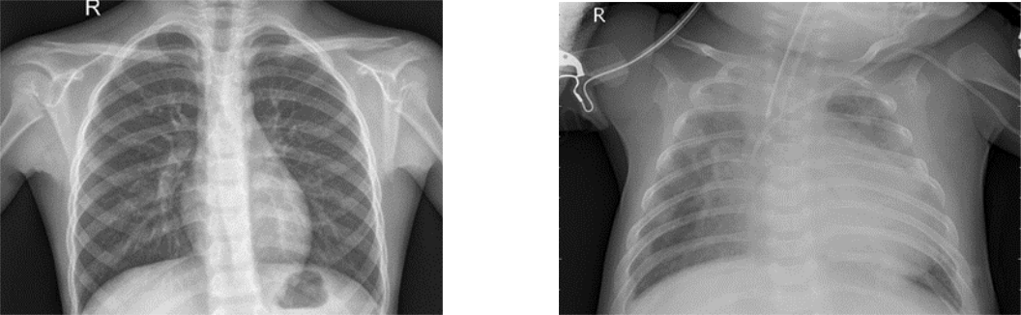

NORMAL ALVEOLI INFECTED

The above picture is a sample from our dataset which is a simple image dataset .Our dataset has chest x ray images which have been divided into 3 files test, train and validation , the training dataset has 89.07% of total images , testing set has 10.6% of images and validation set has 0.27% of total images .These images in these folders are further divided into 2 parts one has NORMAL chest x-rays and rest are in ALVEOLI INFECTED folder based on the information already provided to us we downloaded this dataset from Kaggle

**Accuracy and Score of model**

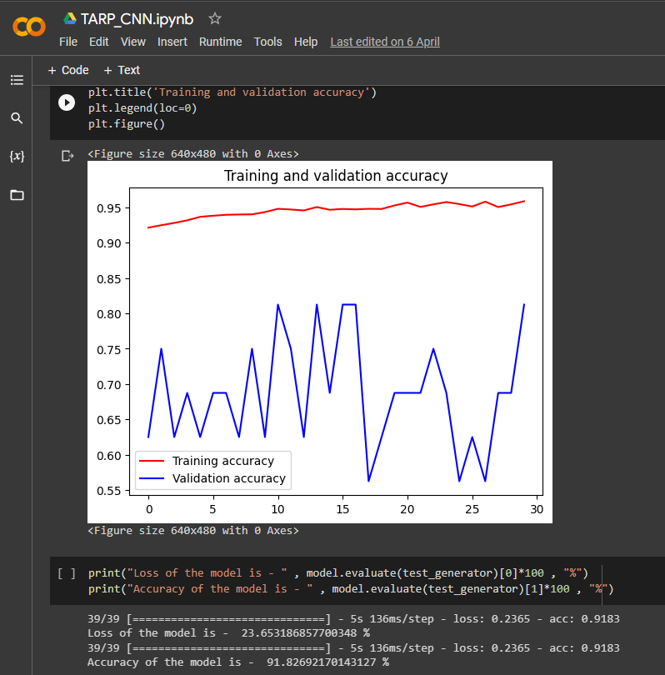

**INPUT IMAGES**:

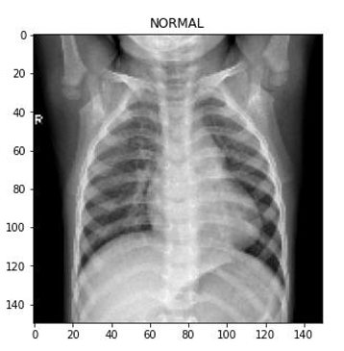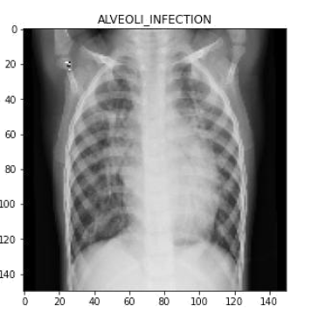

**Epochs**

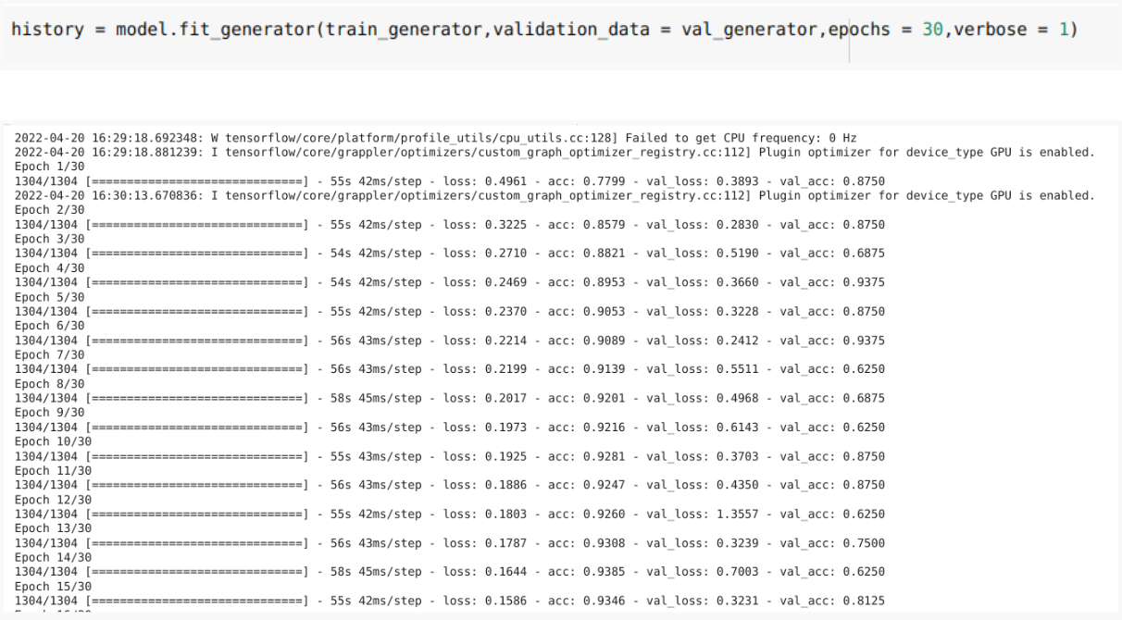

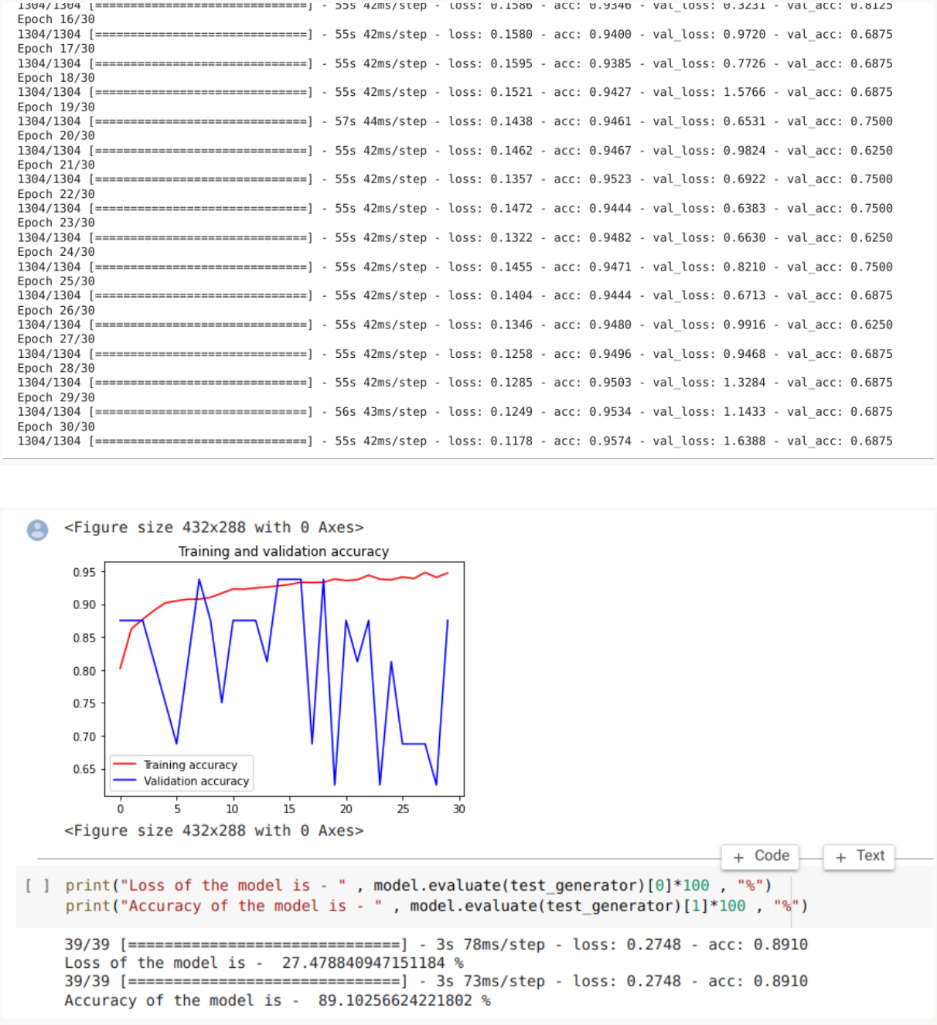

**Result:**





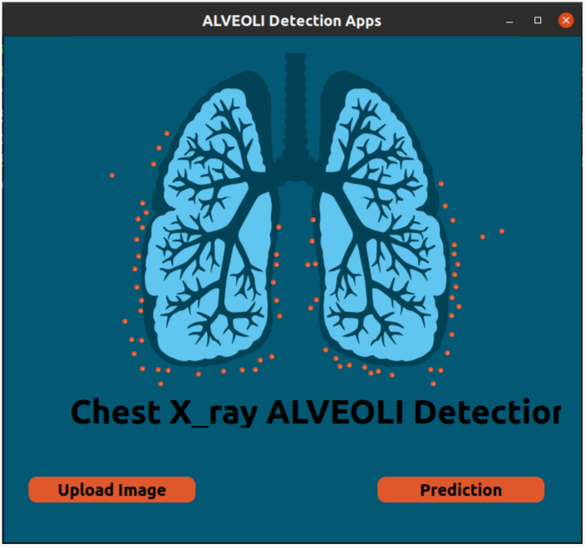

* **COMPARISION WITH OTHER SIMILAR WORKS**

There are several potential advantages to using a neural learning algorithm trained with hyperparameter optimization for detecting alveoli infection in the lungs, compared to other methods available in the market:

1. Higher accuracy: Neural learning algorithms have the ability to learn patterns in large datasets, making them potentially more accurate at detecting infections in the alveoli than other methods.
2. Faster results: Neural learning algorithms can analyze large amounts of data quickly, making them potentially faster at detecting infections in the alveoli than other methods.
3. Lower cost: Once a neural learning algorithm is trained, it can be used to analyze new data at a relatively low cost, making it potentially more cost-effective than other methods.
4. Flexibility: Neural learning algorithms can be customized to specific applications and datasets, making them potentially more flexible than other methods.
5. Non-invasive: Unlike some other methods for detecting alveoli infection, using neural learning algorithms would not require invasive procedures, making them potentially less risky and more patient-friendly.

Overall, using a neural learning algorithm trained with hyperparameter optimization for detecting alveoli infection in the lungs could potentially offer a more accurate, faster, cost-effective, flexible, and non-invasive option compared to other methods available in the market.

There are several methods available for detecting alveoli infection in the lungs. Here are some of the most common methods, along with their potential advantages and disadvantages compared to neural learning algorithms trained with hyperparameter optimization:

|  |  |  |
| --- | --- | --- |
| **Method** | **Advantages** | **Disadvantages** |
| Chest X-ray | Widely available, relatively inexpensive | Low sensitivity, requires radiation exposure |
| Computed Tomography (CT) scan | High resolution , can detect small abnormalities | High cost, radiation exposure |
| Bronchoscopy | Direct visualization of lungs, can obtain tissue samples for analysis | Invasive, requires anesthesia, higher cost |
| Blood tests | Non-invasive, can detect biomarkers of infection | Not specific to alveoli infection, may require multiple tests |
| Sputum analysis | Non-invasive, can detect infectious agents | Can be difficult to obtain adequate sample, not specific to alveoli infection |

Here is a comparison table of these methods compared to neural learning algorithms trained with hyperparameter optimization:

|  |  |  |  |  |  |  |
| --- | --- | --- | --- | --- | --- | --- |
| **Criteria** | **Chest X-ray** | **Bronchoscopy** | **Blood tests** | **Sputum Analysis** | **Neural learning algorithm** | **CT Scan** |
| Accuracy | High | High | Moderate | Moderate | Potentially high | Moderate |
| Speed | Fast | Slow | Fast | Moderate | Potentially fast | Moderate |
| Cost | High | High | Moderate | Low | Potentially low | Low |
| Flexibility | Limited | Limited | Limited | Limited | Limited | High |
| Invasiveness | Non-invasive | Non-invasive | Invasive | Non-invasive | Non-invasive | Non-invasive |

Overall, while each method has its own advantages and disadvantages, a neural learning algorithm trained with hyperparameter optimization could potentially offer a highly accurate, fast, cost-effective, flexible, and non-invasive option for detecting alveoli infection in the lungs. However, the effectiveness of such an algorithm would depend on the quality and quantity of the data used to train it, as well as other factors such as the specific algorithms and hyperparameters used.

* **CONCLUSION**

In conclusion, the goal of our study was to create a deep learning-based method for automatically identifying alveolar infections from chest X-ray pictures. Using a CNN-Sequential Model and a sufficient dataset split into training, test, and validation, sets for testing and validation. In order to increase the precision of our model, we also pre-processed the images. Given the severity of the condition and the vulnerability of healthcare systems, it is imperative to create an accurate and effective diagnostic system for alveoli infection. By successfully implementing our strategy, the diagnosis process can be accelerated and more accurately, which will ultimately result in better patient outcomes. Our results show that deep learning techniques have applications in healthcare, particularly in the area of disease diagnosis, and we hope that our work stimulates additional study in this sector.

* **REFERENCES**

[1] Pneumonia Detection from Chest X-ray Using Mask R-CNN, S. Roshini, R. Sanjana, K. B. Ranjith, M. Karthick (2021)

[2] Classification of Images of Childhood Pneumonia using Convolutional Neural Networks by A. A. Saraiva , N. M. Fonseca Ferreira, Luciano Lopes de Sousa , Nator Junior C. Costa , Jose Vigno Moura Sousa ´ , D. B. S. Santos , Antonio Valente, g and Salviano Soares(2019)

[3] Analysis of Various Optimizer on CNN model in the Application of Pneumonia Detection by Yuvraj Sinha Chowdhury, Rupshali dasgupta, Sarita Nanda

[4] PNEUMONIA DETECTION USING CNN THROUGH CHEST X-RAY by HARSHVARDHAN GM, MAHENDRA KUMAR GOURISARIA, SIDDHARTH SWARUP RAUTARAY*, MANJUSHA PANDEY

[5] Diagnosis of Paediatric Pneumonia with Ensemble of Deep Convolutional Neural Networks in Chest X‑Ray Images by Enes Ayan,Bergen Karabulut ,Halil Murat Ünver

[6] COVINet: a convolutional neural network approach for predicting COVID‑19 from chest X‑ray images by Muhammad Umer,Saleem Ullah,Arif Mehmood,Gyu Sang Choi

[7] Convolutional Neural Network Based Classification of Patients with Pneumonia using X-ray Lung Images by Hicham Moujahid1 , Bouchaib Cherradi1, Oussama El Gannour , Lhoussain Bahatti1 , Oumaima Terrada1 , Soufiane Hamida

[8] Pneumonia Detection through Adaptive Deep Learning Models of Convolutional Neural Networks by Sammy V. Militante,Nanette V. Dionisio,Brandon G. Sibbaluca

[9] Classification of Images of Childhood Pneumonia using Convolutional Neural Networks by A. A. Saraiva1 a , N. M. Fonseca Ferreira , Luciano Lopes de Sousa , Nator Junior . Costa5 d , Jose Vigno Moura Sousa e , D. B. S. Sant

[10] Pneumonia Detection Using Convolutional Neural Networks by Puneet Gupta (2021)

[11] Pneumonia Detection Using Convolutional Neural Networks by Sammy V. Militante, Brandon G. Sibbaluca (2020)

[12] Detection and classifcation of lung diseases for pneumonia and Covid‑19 using machine and deep learning techniques Shimpy Goyal, · Rajiv Singh (2021)

[13] Pneumonia Detection Using an Improved Algorithm Based on Faster R-CNN by Shangjie Yao , Yaowu Chen , Xiang Tian and Rongxin Jiang (2021)

[14] Pneumonia Detection Using CNN based Feature Extraction by Dimpy Varshni,Lucky Agarwal, Rahul Nijhawan, Ankush Mittal , Kartik Thakral

[15] Diagnosis of Pediatric Pneumonia with Ensemble of Deep Convolutional Neural Networks in Chest X‑Ray Images by Enes Ayan, · Bergen Karabulut · Halil Murat Ünver (2021)

[16] COVINet: a convolutional neural network approach for predicting COVID‑19 from chest X‑ray images by Muhammad Umer, · Imran Ashraf,· Saleem Ullah,· Arif Mehmood,· Gyu Sang Choi

[17] Convolutional Neural Network Based Classification of Patients with Pneumonia using X-ray Lung Images by Hicham Moujahid, Bouchaib Cherradi, ,* , Oussama El Gannour , Lhoussain Bahatti , Oumaima Terrada , Soufiane Hamida

[18] Pneumonia Detection through Adaptive Deep Learning Models of Convolutional Neural Networks Sammy by V. Militante, Nanette V. Dionisio, Brandon G. Sibbaluca (2020)

[19] Classification of Images of Childhood Pneumonia using Convolutional Neural Networks by A. A. Saraiva1, N. M. Fonseca Ferreira , Luciano Lopes de Sousa, Nator Junior C. Costa, Jose Vigno Moura Sousa , D. B. S. Santos, Antonio Valente and Salviano Soare

* **INDIVIDUAL ROLE AND PERCEPTION**

**Arjeet Anand**

